TERRAFORM TASK -03
Watch the Terraform-03 video.

Execute The Script Shown In The Video.
When we execute terraform apply it will create random id with pet name
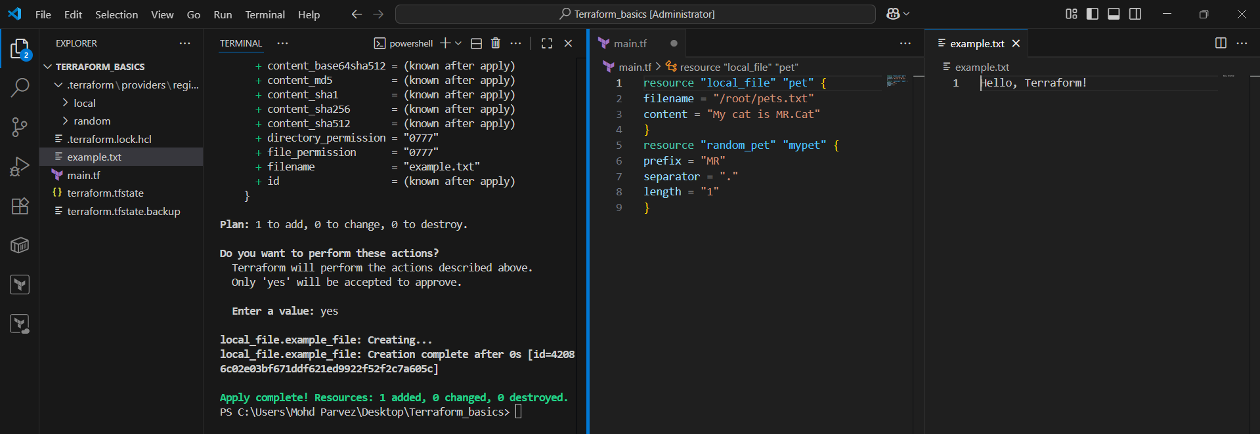
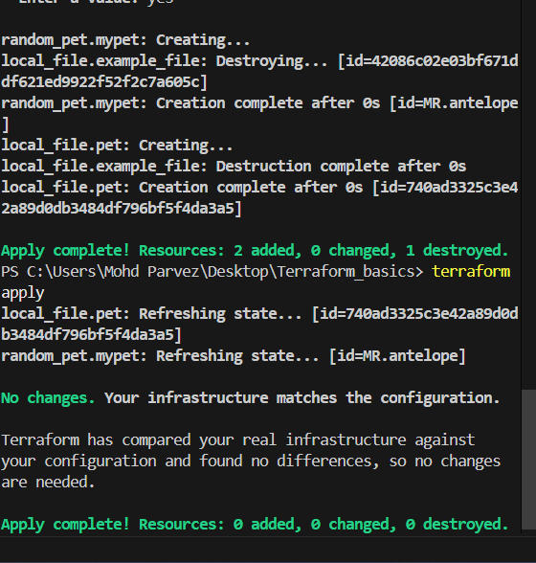
“
Terraform show” command will show the infrastructure of the file or content
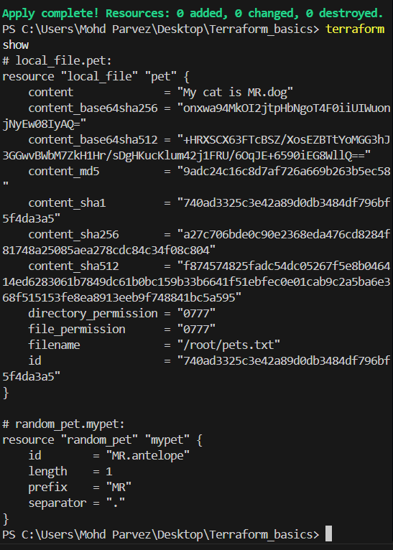

Output variables if you add output variables in file after apply it will show the output that you define

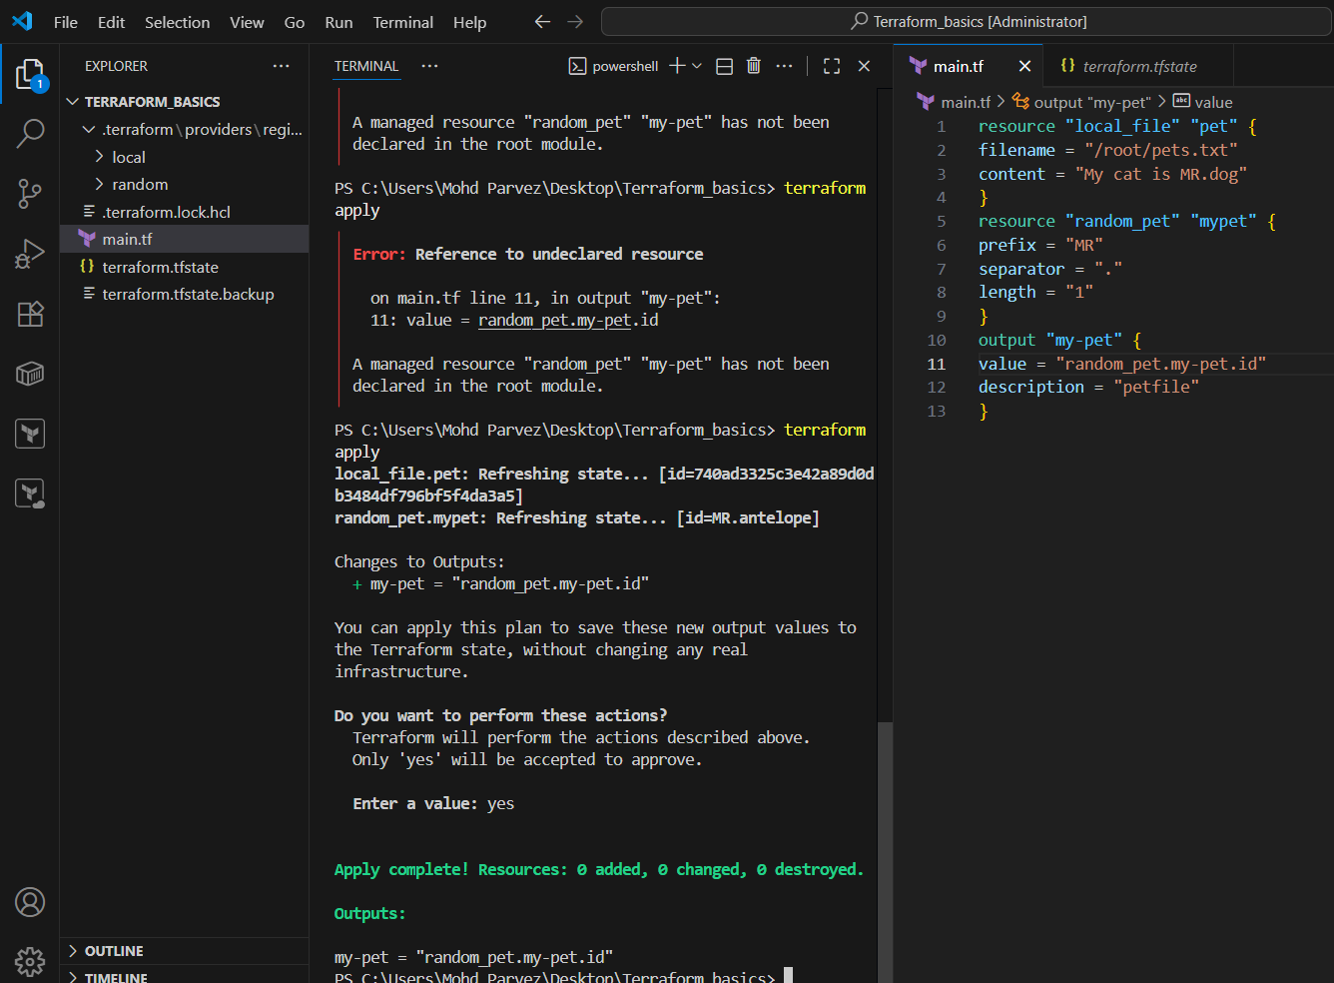

Integrate Terraform in Jenkins using the Terraform plugin.
Download the terraform plugin in the Jenkins and add the aws credentials and add the credentials

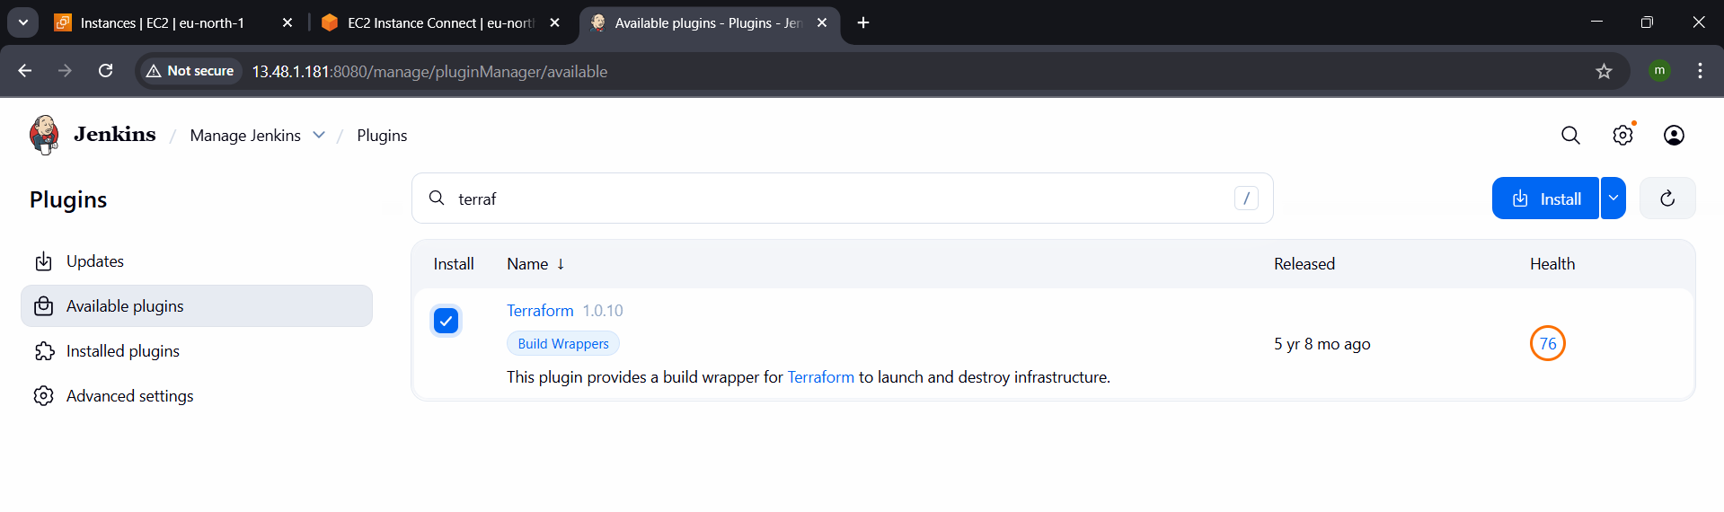
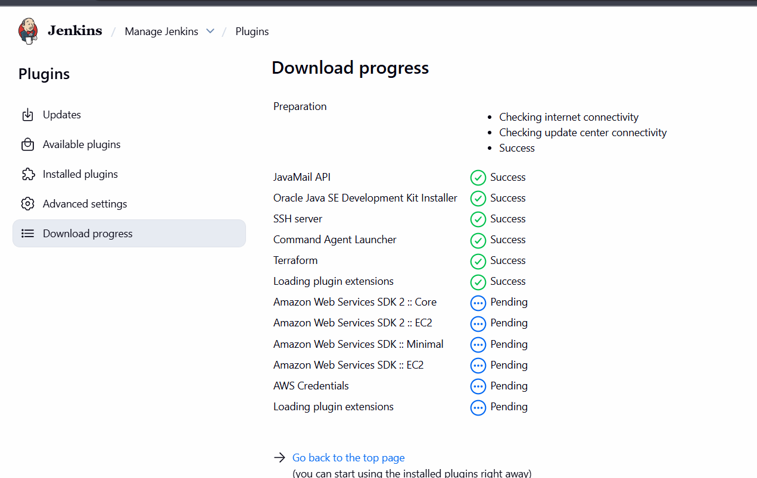
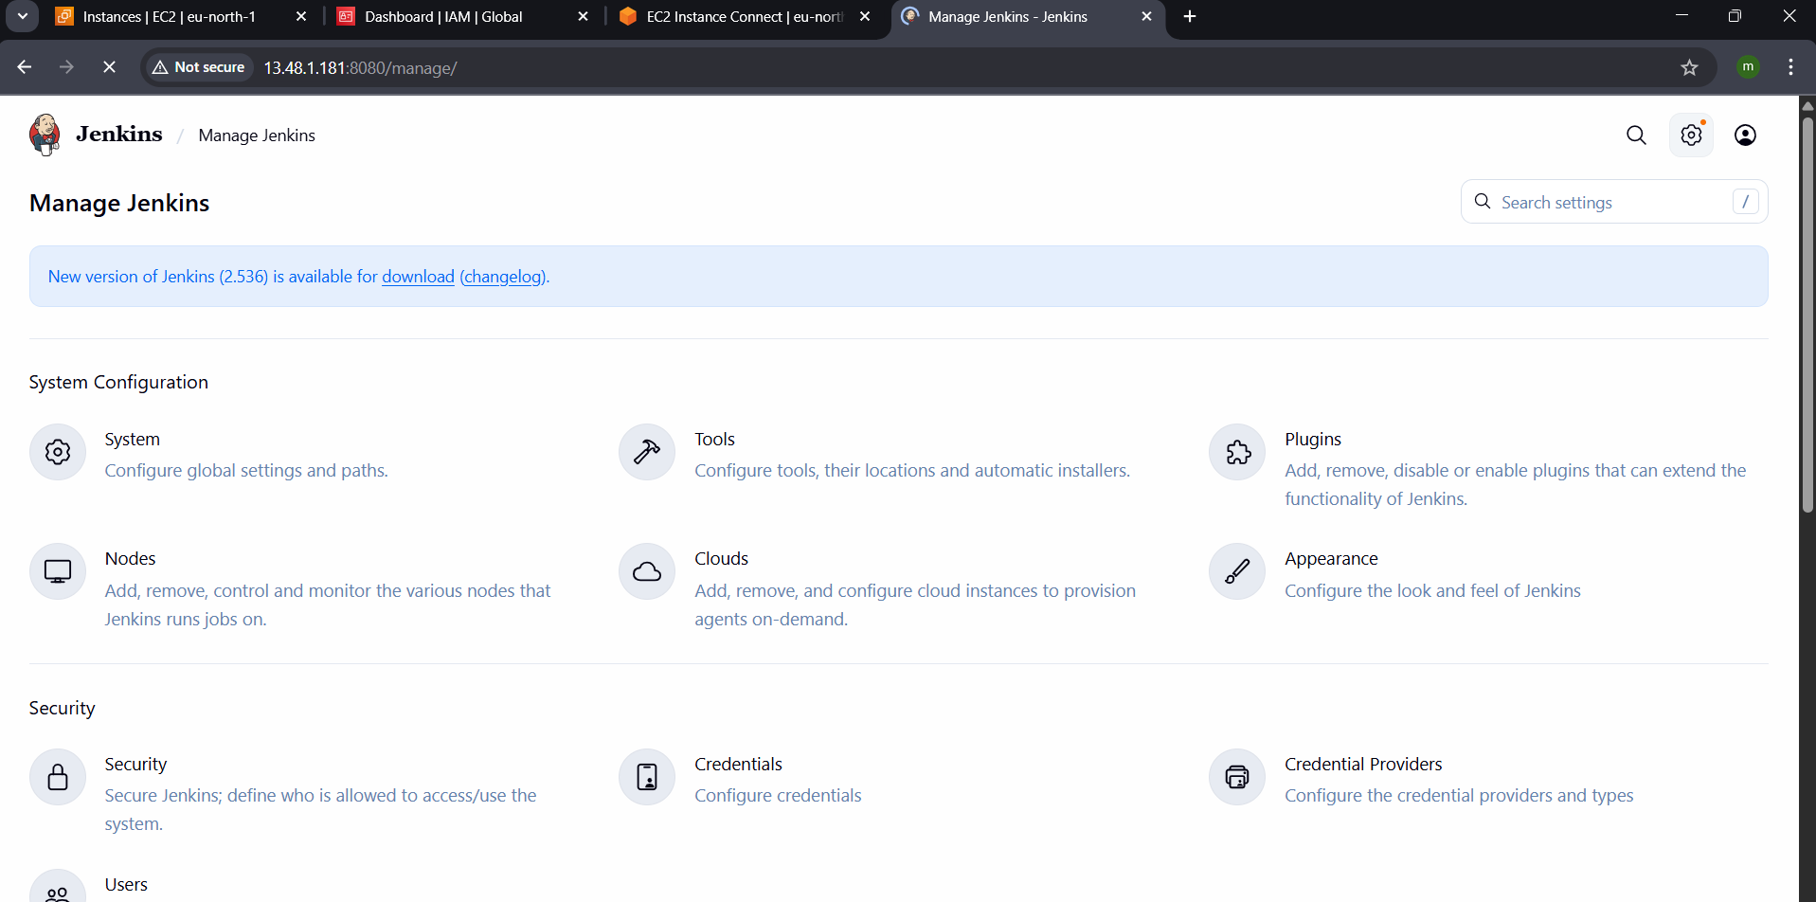
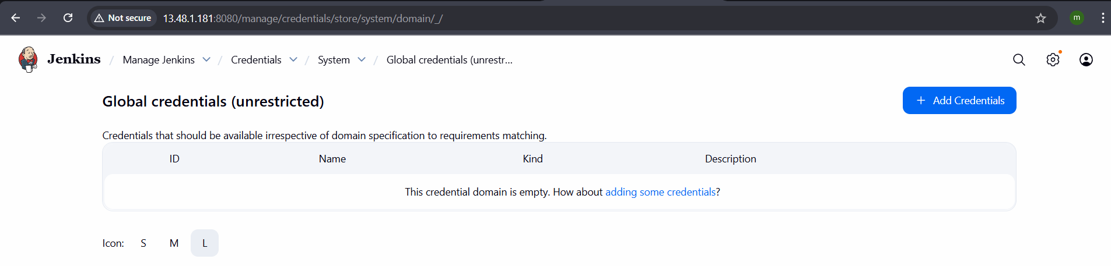

Create one Jenkins job using Maven Project for the code below with two stages:
Stage 1: Git clone
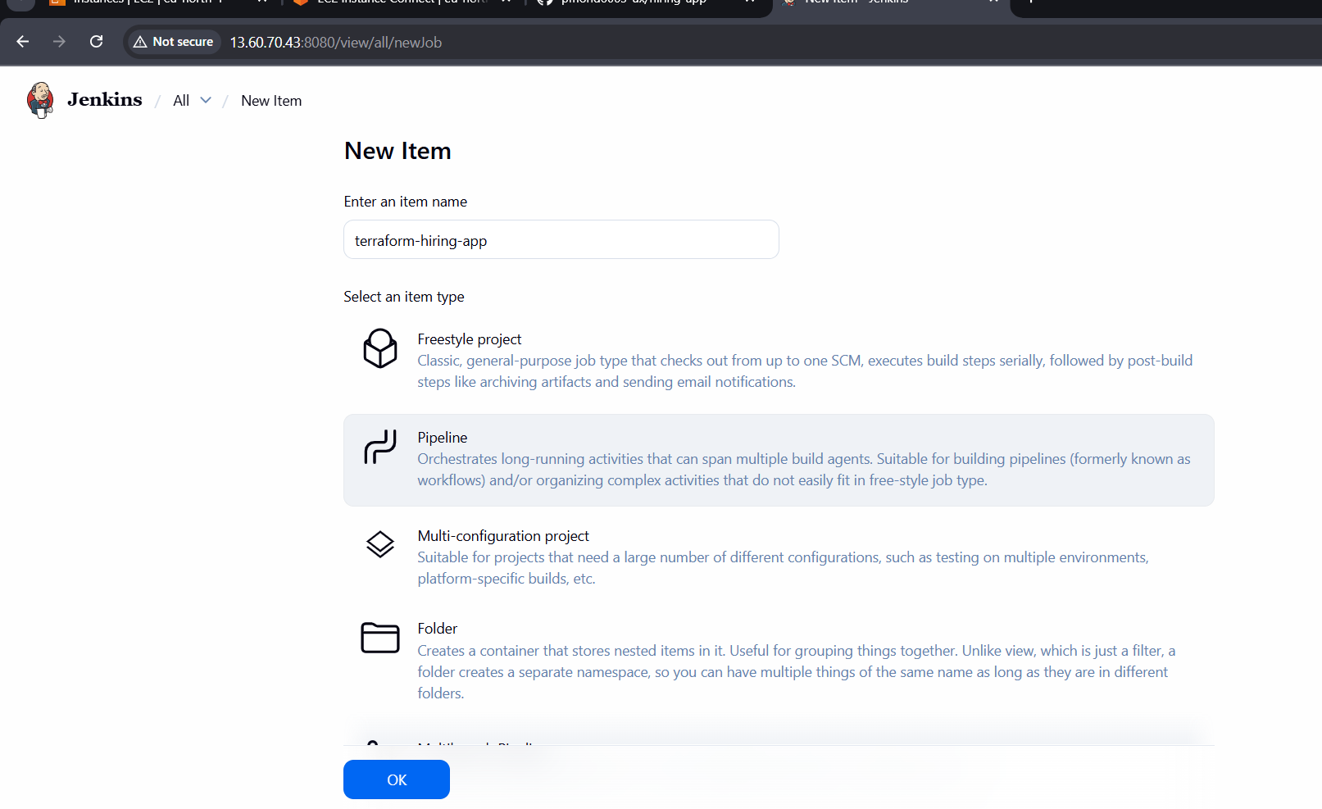
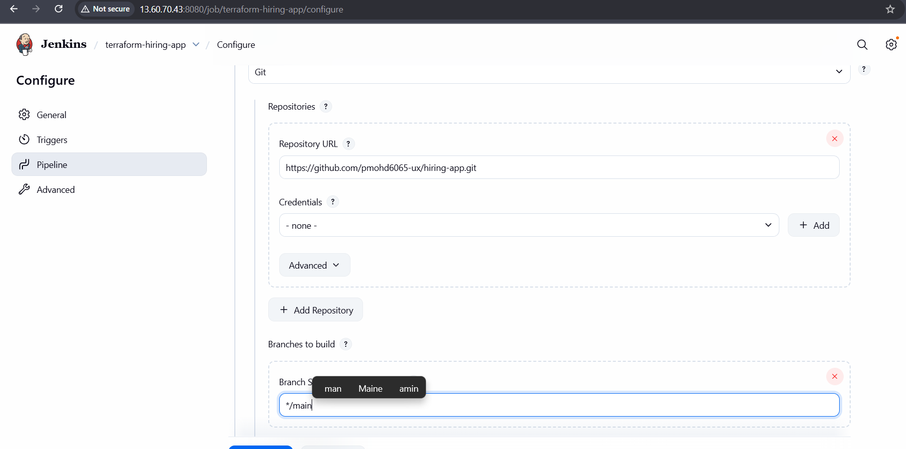

Stage 2: Maven Compilation Code: https://github.com/betawins/java-Working-app.git
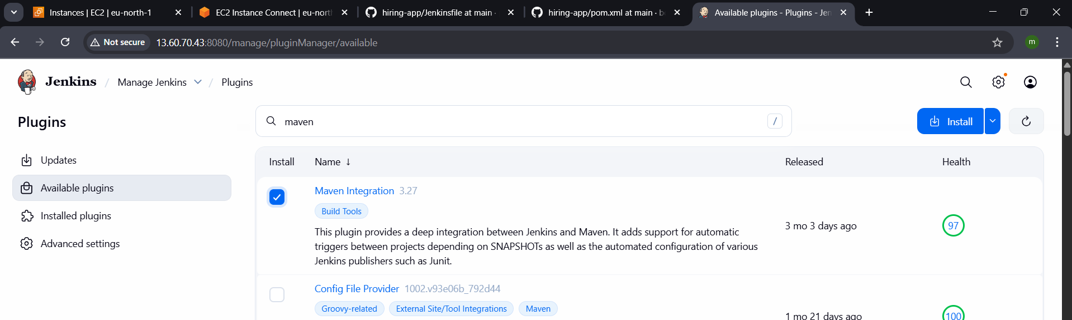
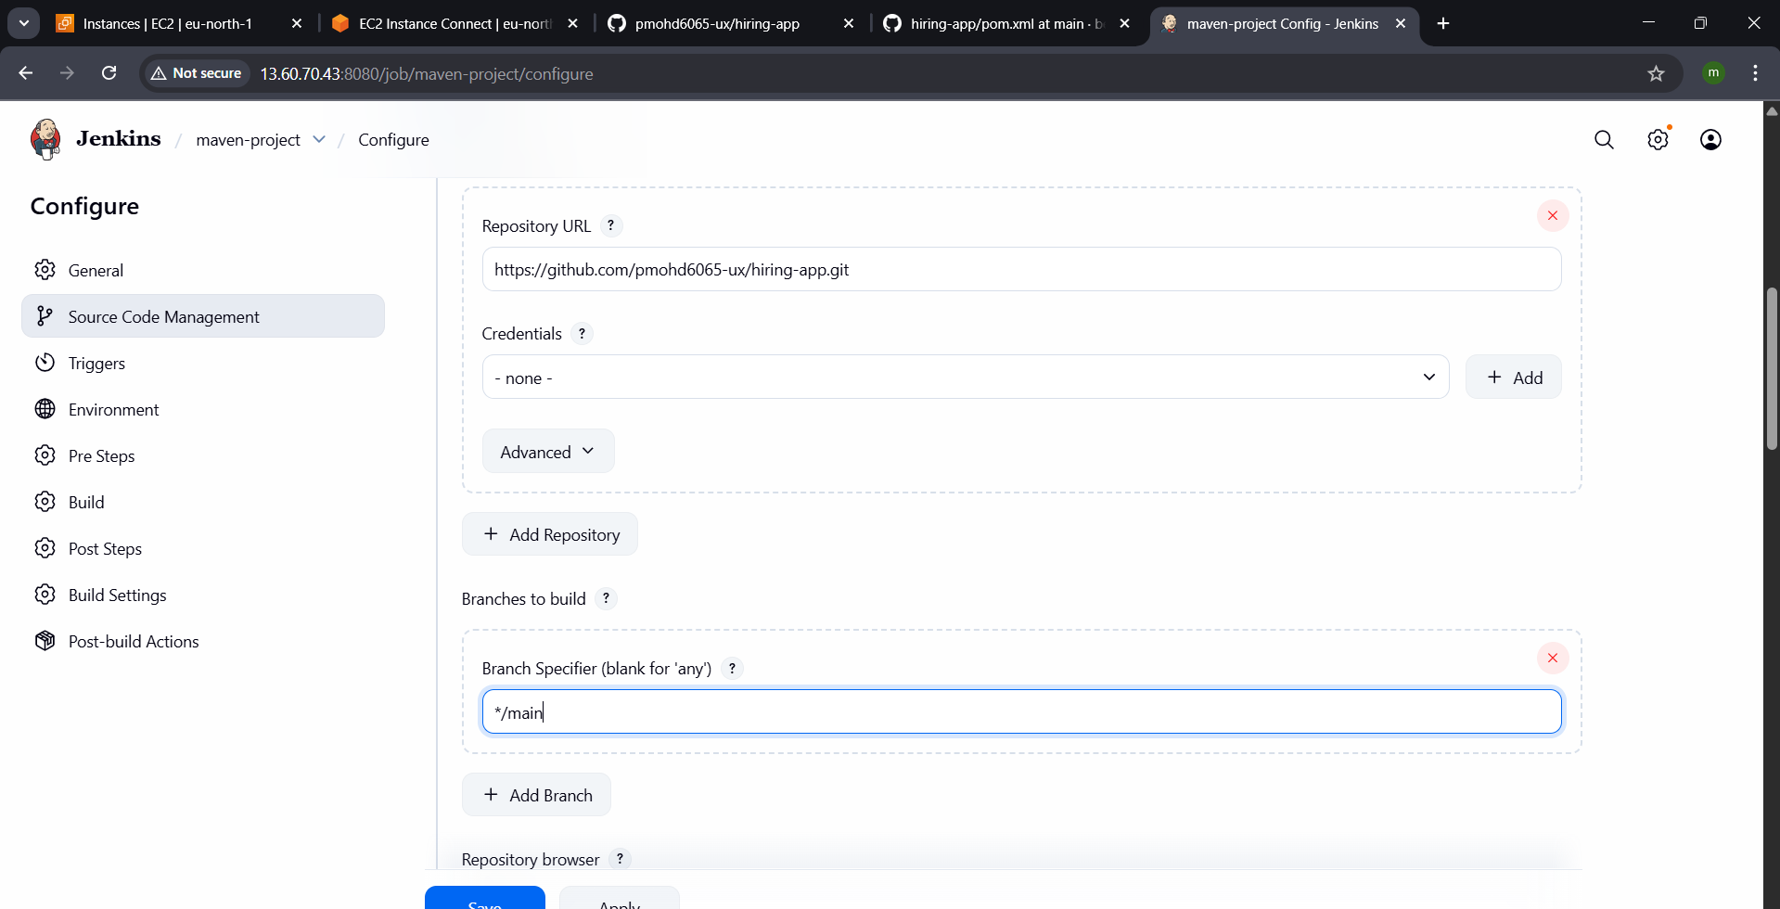
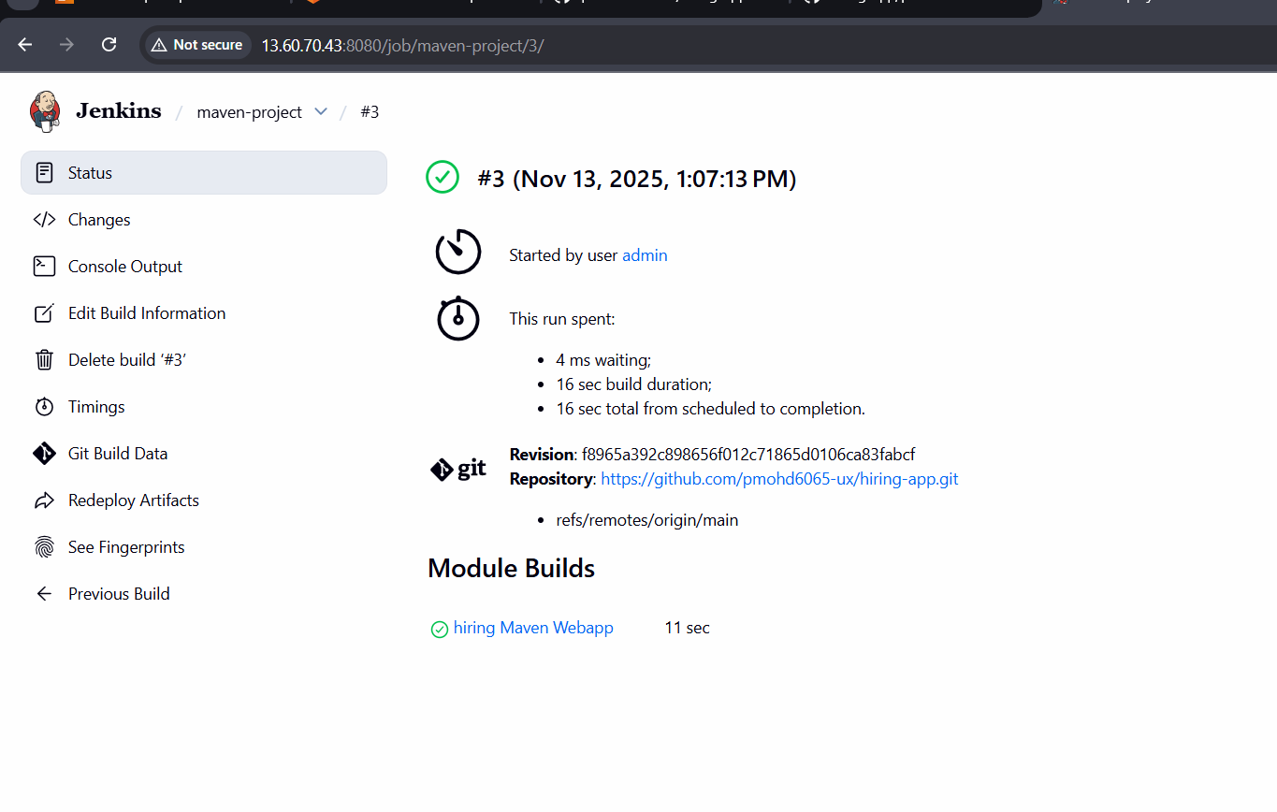
Use the same code and create a parameterized job in Jenkins with:
Stage 1: Git clone
Stage 2: Maven Compilation Code: https://github.com/betawins/java-Working-app.git
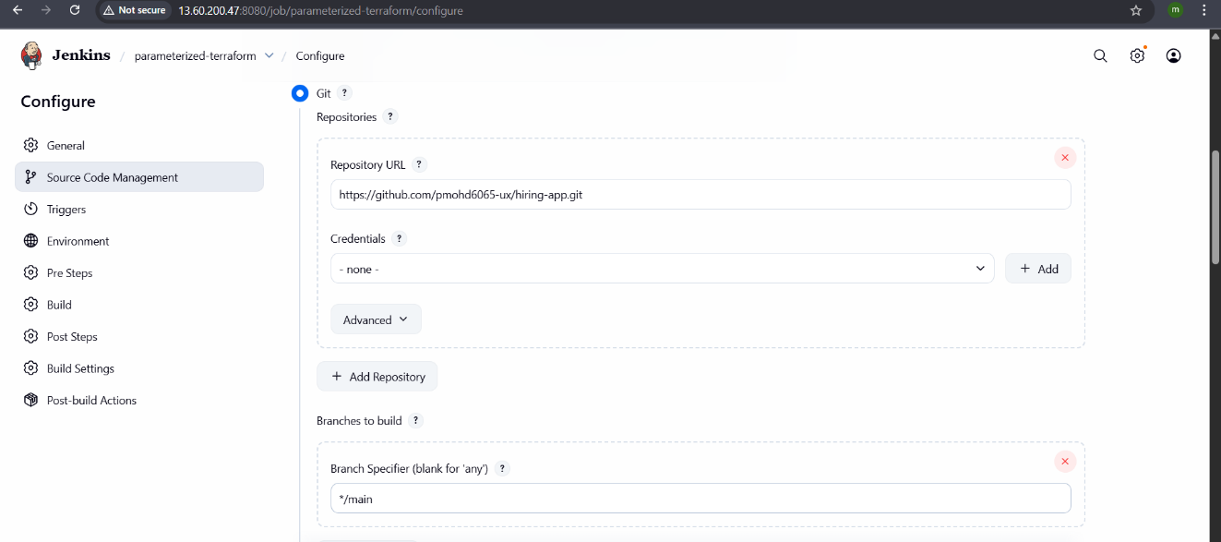
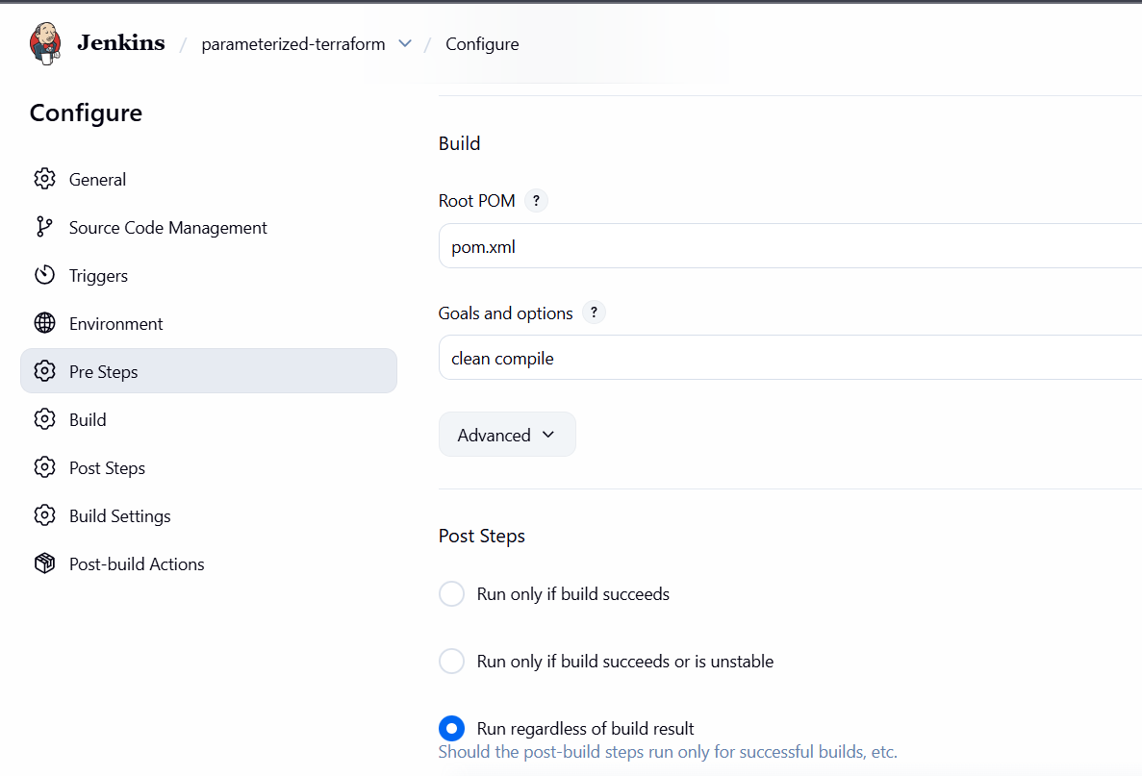
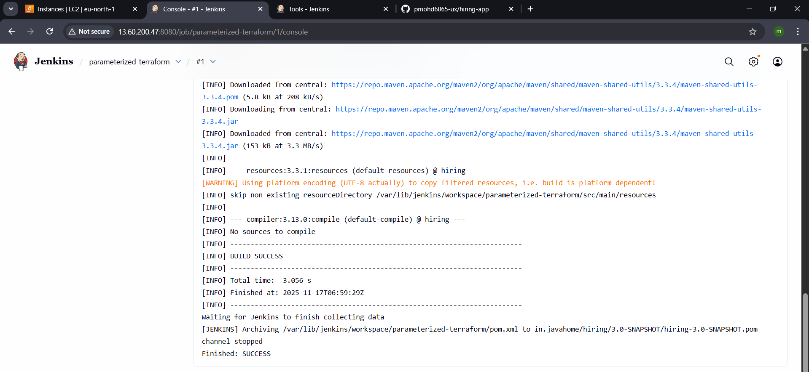
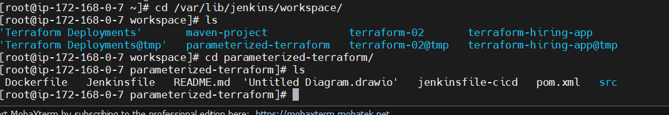

What are the global variables in Jenkins?
If you see the commands like if you have installedd something on your server you check with commands for example: java : java –version see the versionof java which you will be using and you need to pass the global variables to call from any where and should show the service and the version
Global variables 